Solving equation:

a) 5x + y + z + u = 4

x + 7y + z + 4u = 6

3x + y + 6z + u = -5

x + y + z + u = 0

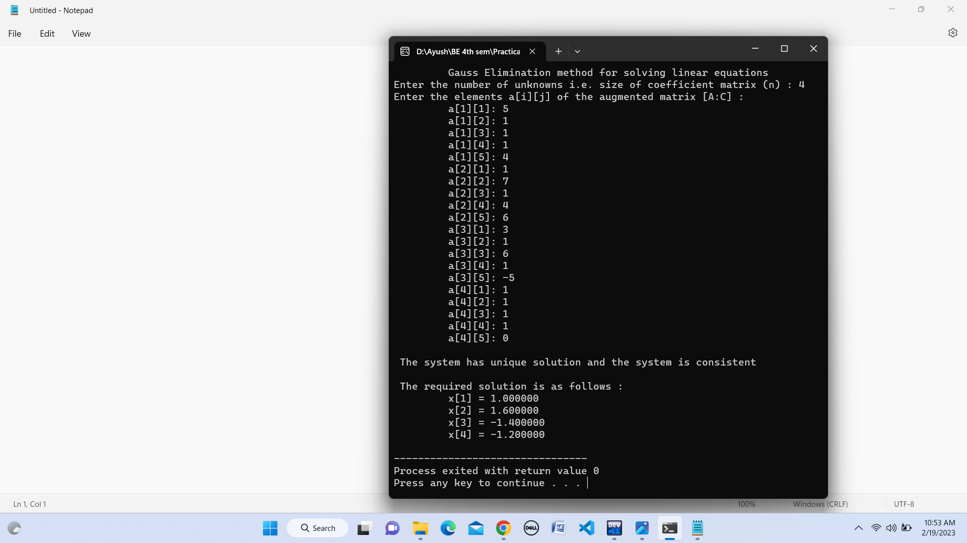

b) x + 3y + 4z = 8

2x + y + 2z = 5

5x + 2z = 7

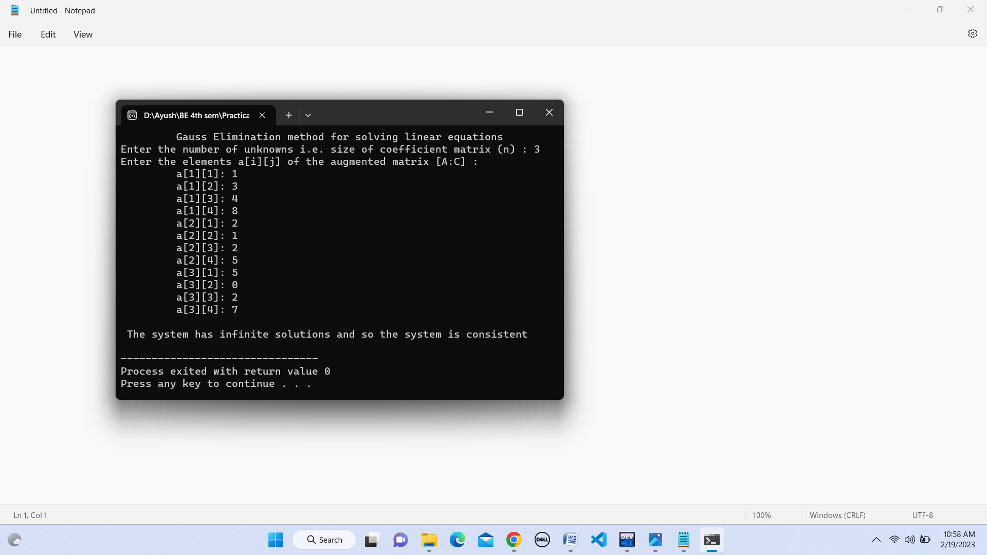

c) x + y + z = -3

3x + y - 2z = -2

2x + 4y + 7z = 7



Solving equation:

a) 2x + y + z - 2u = 10

4x + 2z + u = 8

3x + 2y + 2z = 7

x + 3y + 2z - u = -5

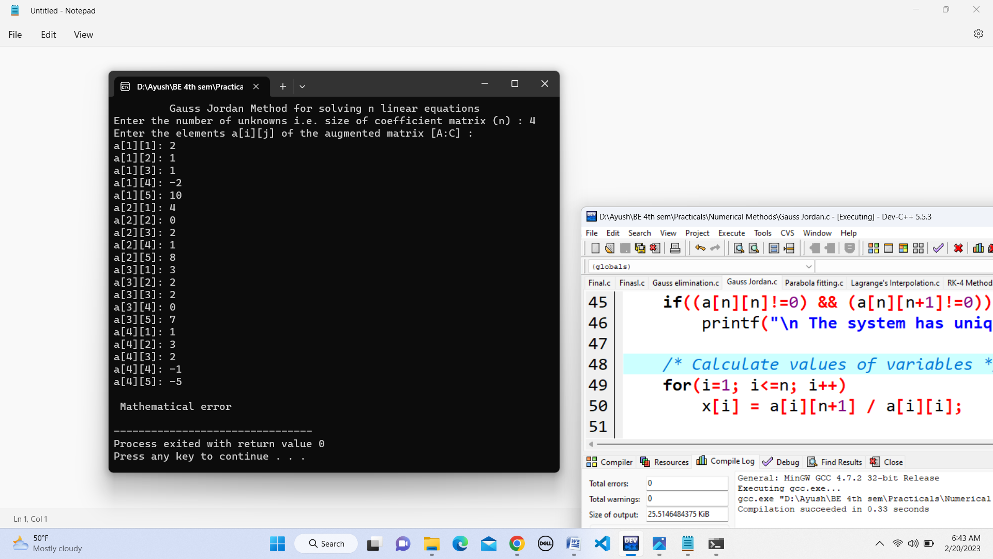

In this system of linear equations as element of main diagonal is 0, there is mathematical error. But, on exchanging the first two equations (i.e. making first equation second and second as first), the solution gets produced as:

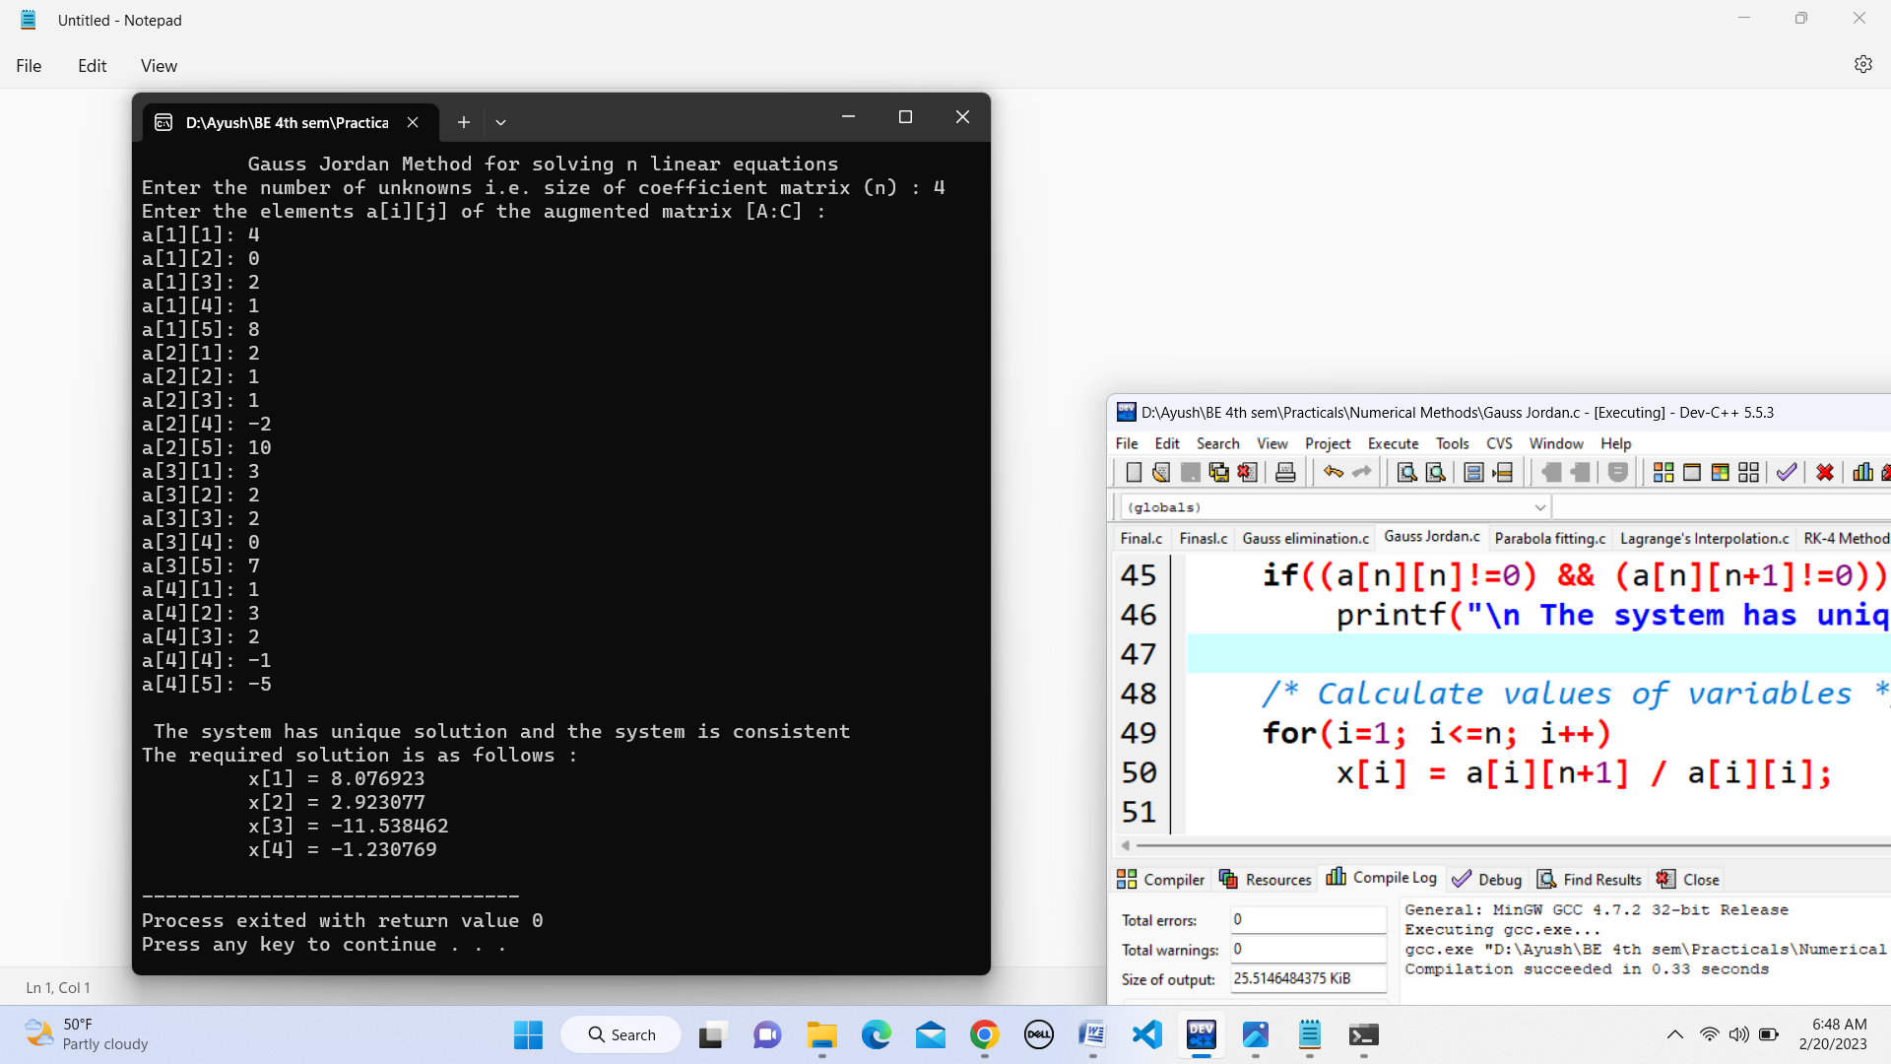

b) 20x + y - 2z = 17

3x + 20y - z = -18

2x - 3y + 20z = 25

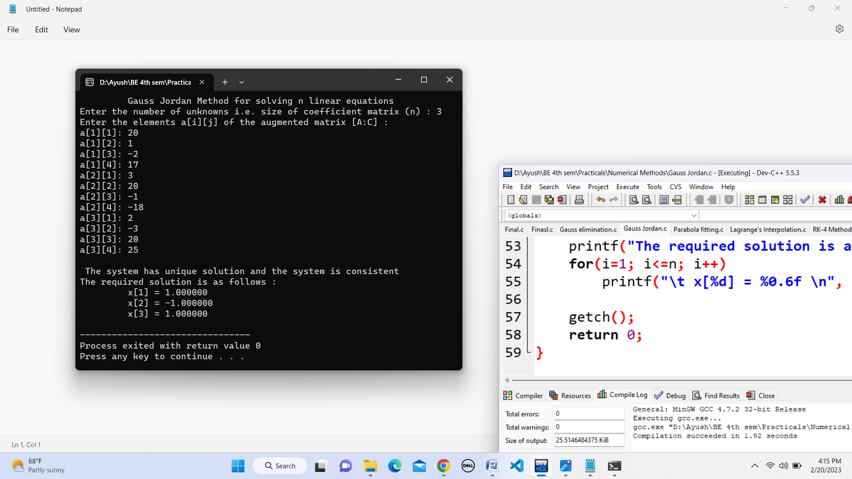

Parabola fit for the data given below:

|  |  |  |  |  |  |
| --- | --- | --- | --- | --- | --- |
| x | 0 | 1 | 2 | 3 | 4 |
| y | 1 | 1.8 | 1.3 | 2.5 | 6.3 |

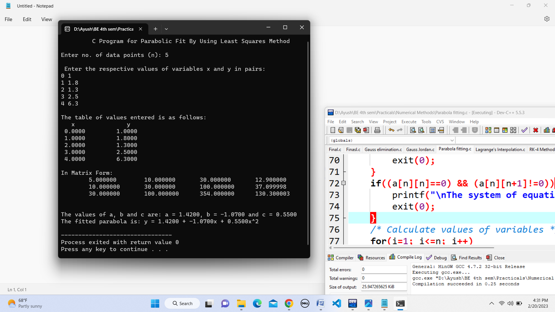

Apply Lagrange’s Interpolation Formula to find polynomial f(x) which passes through the points:

1. (0,2),(1,3),(2,12),(5,147) and estimate f(1.5),f(2),f(3),f(4),f(5)

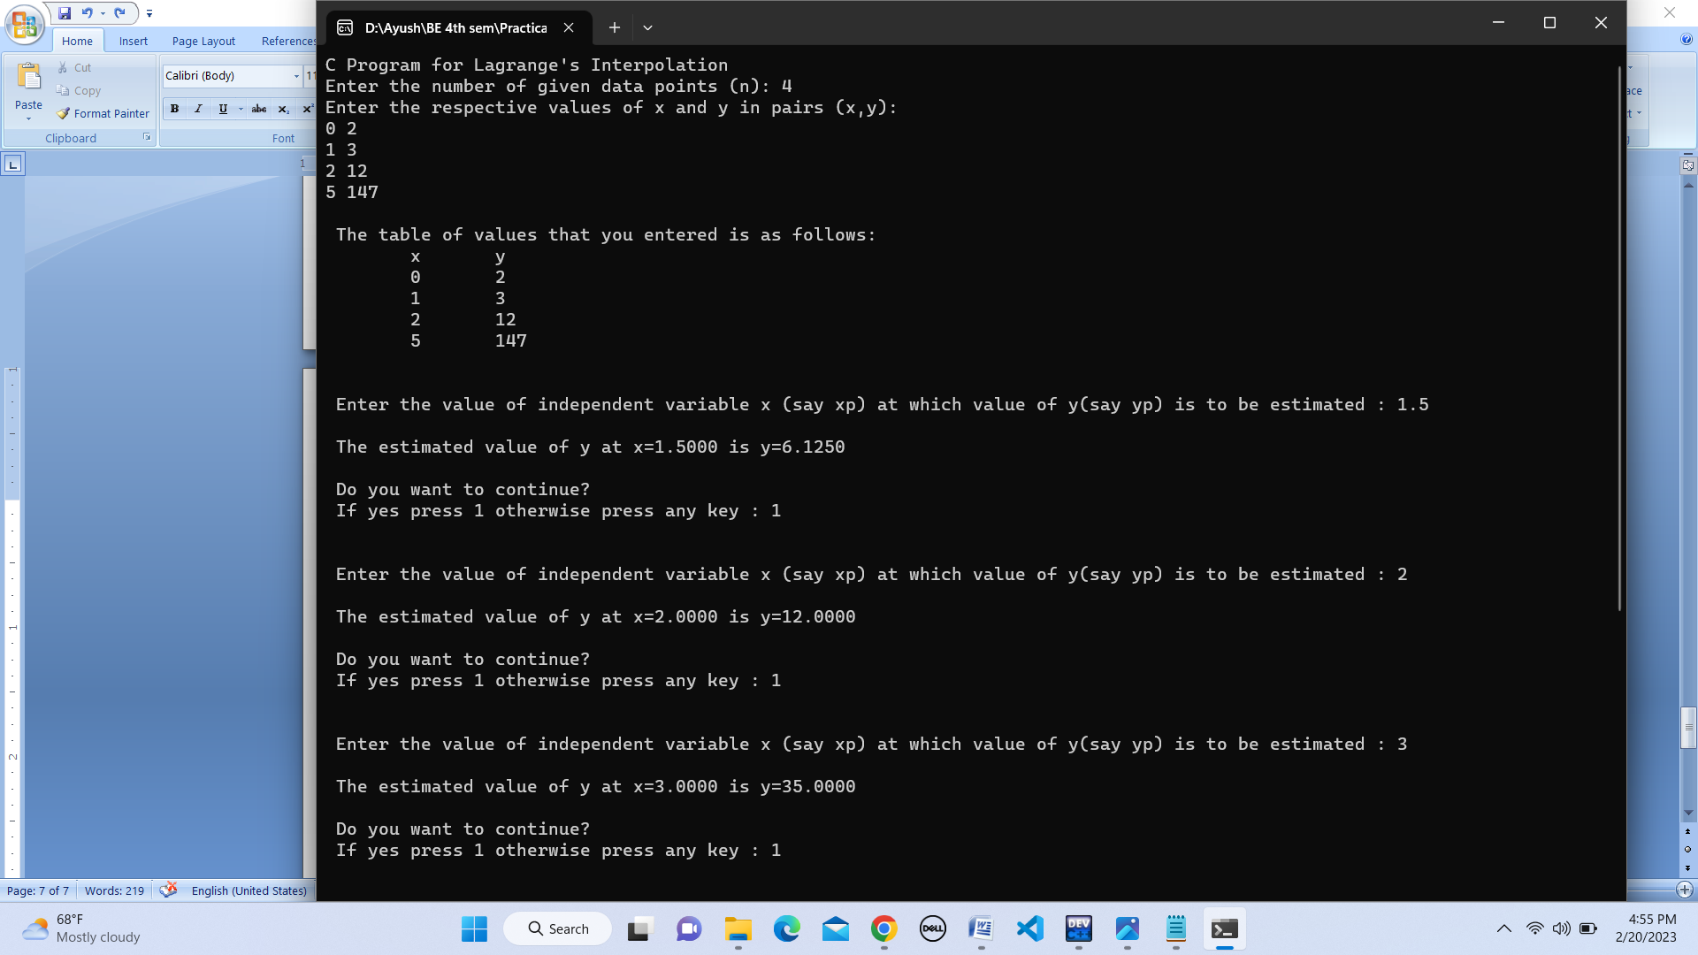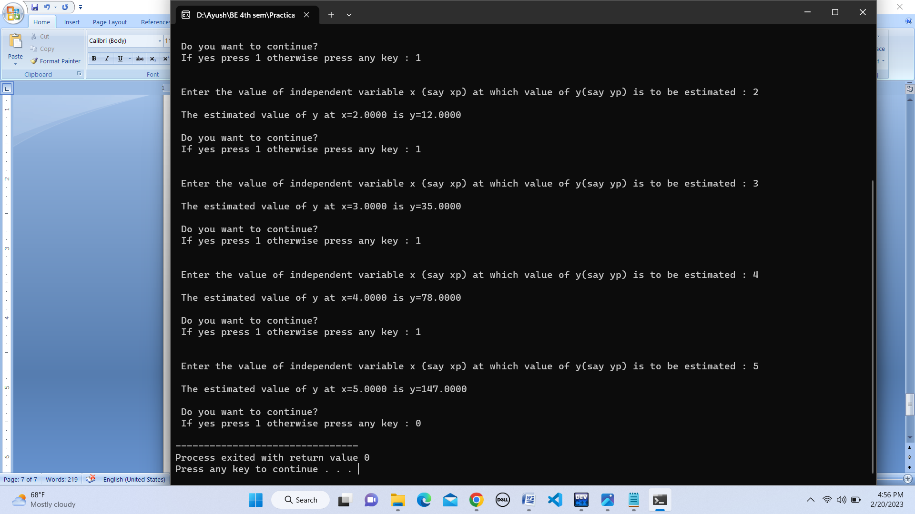

1. (0,18),(1,10),(3,-18),(6,90) and hence estimate f(0),f(1),f(2),f(3)

